**Optimizing the**

**Marker Efficiency**



Group 1 | MT 325|

# **Group Members**

* S/17/802 – G D M P Amarasooriya
* S/18/803 – A T R Akalanka
* S/18/805 – B D Colombage
* S/18/806 – C Danusiyan
* S/18/807 – P M R S Fernando
* S/18/808 – P R N Fernando
* S/18/809 – G Sathushana
* S/18/811 – M A E Hasheli

# **Acknowledgement**

It is with immense pleasure, appreciation and heartiest gratitude that we take this opportunity to thank and acknowledge the help, guidance and comments of all who contributed in one way or the other in making this project feasible.

First and foremost our sincere gratitude goes to Prof. W.B. Daundasekara & Ms. W.N.P. Rodrigo for guiding us and sharing their experience with us.

A Special thanks goes to Mr. Dinesh Gunathilake (Brandix Fast Fashion - Walisara , who committed to provide necessary information for this project and we also highly appreciate the great support of the employees in Brandix Apparel Limited.

Last but not least, we also would like to thank all our colleagues who have been working with us on this project.

# **Table of Content**

**Group Members** 1

**Acknowledgement** 2

**Abstract** 3

**1. Introduction** 5

**1.1 company Overview** 5

**1.2 Garment Manufacturing Process** 5

**1.3 Problem Statement** 6

**1.4 Literature Study** 6

1.4.1 Marker 6

1.4.2 Marker making 6

1.4.3 Marker efficiency 6

1.4.4 Constraints of Marker Making 8

1.4.5 Marker Making Methods 9

**2. Methodology** 10

**3. Data and Results**  12

**4.** **Conclusion and Future Work** 17

**4.1 Assumptions** 17

**4.2 Limitations** 17

**4.3 Conclusion** 17

**4.4 Future Work** 18

**References** 19

# 

# **Abstract**

This report explores how Brandix (pvt) Ltd., a major Sri Lankan apparel exporter, can enhance its fabric utilization in the garment-making process. Currently facing challenges with an 80% marker efficiency, the study aims to minimize fabric wastage and reduce production costs.

Key aspects of the report include an overview of the garment manufacturing process, specifically focusing on marker making – the arrangement of pattern pieces on fabric to minimize waste. Factors influencing marker efficiency, such as planner experience, garment size, and fabric characteristics, are highlighted. The study emphasizes two marker-making methods: manual and computerized, with the latter proving more efficient.

Data and results from Brandix are analyzed to achieve the primary objective of maximizing efficiency by optimizing raw material usage. The methodology involves solving a system of linear equations to determine size ratios for optimal marker efficiency. The study applies this methodology to two garment designs, demonstrating its effectiveness in meeting order quantities while minimizing fabric wastage.

Assumptions include no overlapping of garment pattern pieces, and the solving process requires assuming one dependent variable is greater than or equal to 1. The study concludes that the developed methodology effectively minimizes marker wastage, offering practical insights for apparel manufacturers seeking to optimize efficiency, reduce fabric costs, and improve profitability.

In summary, this report provides a simplified approach for Brandix to enhance fabric utilization, offering solutions for minimizing wastage and improving overall efficiency in garment production.

# **1. INTRODUCTION**

## **1.1 company Overview**

Brandix (pvt) Ltd is considered to be a leading apparel manufacturing firm in Sri Lanka. It is Sri Lanka’s single largest apparel exporter with an annual revenue exceeding $800 million which possess 50 years of experience. Brandix employs over 40000 employees with vision is to be the inspired solution for the branded clothing. Values of the company are Respect, Integrity, Teamwork, Excellence and their products represent Value Propositions of:

* Phenomenal products
* Faster than anyone
* Flawless execution
* Optimal pricing
* Intimate service

Products are mainly categorized into four categories such as Casualwear, Intimate wear, Sleep and lounge wear and Active wear.

**Main Operations**

* Raw material sourcing
* Cutting and Embellishments
* Design and Developments
* Sewing operations
* Quality control
* Finished goods
* Packing and Distribution

## **1.2 Garment Manufacturing Process**

Garment manufacturing is a complex process which convert raw materials into finished products.

Generally, apparel manufacturing process involves Product Design, Fabric Selection and Inspection, Pattern making, Grading, Marker Making, Spreading, Cutting, Bundling, Sewing, etc.

Among those many steps, our interest lies in marker making.

## **1.3 Problem Statement**

Marker making process which does not have ideal efficiency leading to higher fabric cost:

The current utilization on a marker stands at 80%. Therefore, marker making process is not efficient enough for the cutting department. This is a significant challenge as it result in higher fabric cost. The organization is experiencing increased expenditure due to this underutilization of fabric in cutting phase.

## **1.4 Literature study**

### 1.4.1 Marker

After receiving an order, according to the customer requirements designers design the garment and each component of the garment which is called pattern.

A marker is a diagram of precise arrangement of all pattern pieces for sizes of a specific style that are to be cut from one spread of fabric. The thin and transparent paper on which all necessary different pattern pieces for all sizes for a particular style of garment are placed to collect their replica for smooth cutting of fabric is called a marker.

This is done in such a way that the fabric wastage would be least. It will ultimately reduce total cost of garment item.

Width of the marker will be the width of the fabric. Marker length is mainly depend on how many sizes of patterns are used and some other factors such as,

* Number of garments made with one lay of fabric.
* The length of the cutting table
* Production planning etc.

### 1.4.2 Marker making

In marker making step all the pattern pieces of all required sizes are arranged in such a way that the maximum number of garments can be produced with minimal fabric waste. It is a process that determine the most efficient layout of pattern pieces for a style, fabric and distribution of sizes.

Main objective of this process is maximize the utilization of fabric. Reducing the amount of fabric used per garment leads to increase the profit. The production cost is reduced for the minimization of the fabric wastage.

### 1.4.3 Marker efficiency

Marker efficiency is the ratio between the summations of the area of all pattern pieces on a marker and total area of that marker expressed as percentage.

(1)

And another formula to measure the efficiency as follows:

(2)

YY : The number of yards it takes to layout a pattern

Following factors are involved with marker efficiency.

1. Marker planner
2. Size of garments
3. Marker length
4. Pattern Engineering
5. Marker making method
6. Fabric characteristics
7. Marker width
8. Style of garments

#### Marker planner

The planner’s experience, honesty, sincerity, effort and technological knowledge have a significant impact on marker efficiency. The higher the number of markers practiced for a particular style, the more likely it is to achieve a greater efficiency.

#### Size of garments

The more the number of pattern sizes are included, the potential to get a high efficiency is greater. But an excessive amount of pattern may lead to issues.

#### Marker length

When marker length is higher, the efficiency also will be high. Although the length of the marker is related with many factors, the bigger marker length enhanced more production in the cutting room. But the excessive marker length may cause issues.

#### Pattern Engineering

Marker efficiency can also be increased by changing the pattern design or alternating the patterns’ position on the marker.

#### Marker making method

Markers can be made using two methods. One is manual method and other one is computerized method. Computerized marker is more efficient than manual marker. But, when the marker maker is highly experienced manual method may enhanced more efficiency.

#### Fabric characteristics

A symmetric fabric are those which can be turn 180 degrees in same plane but there is no visible difference in the appearance. If the fabric is symmetric then the efficiency will be high. If the fabric is asymmetric, the efficiency will be less. If the fabric is cheeked or stripped then the marker efficiency will be obtained less.

#### Marker Width

Marker width normally depend on the fabric width. If the marker width is more, then the efficiency of the marker will be more because pattern can be placed in the marker easily. But for the tubular fabric this may not be the case.

#### Style of garment

There are some garments that have only large patterns. The efficiency of the marker will be decreased as the number of small components decreases. That is because there are no small patterns to be placed after placing large patterns to fill the remaining gaps. So the gaps remain unfilled, which causes the fabric waste.

### 1.4.4 Constraints of marker making

Although we always want to plan the marker with maximum efficiency to ensure the highest use of fabrics, it is always not possible to place the pattern pieces as desired. The reason for this is that we have to keep certain requirements in mind during planning.

Those constraints are;

1. The nature of the fabric and the desired result in the finished garments.

* Pattern alignment in relation to the grain line of the fabric:

Pattern pieces must carry the grain line when they are laid down on the marker paper and the grain line should be parallel to the wrap or wales. The grain line should line up with the weft or course when laid across the fabric. The finished garment will not hang or drape correctly when worn if the marker planner does not pay attention to the grain line.

* + Fabric symmetry or asymmetry:

It is important to plan the marker according to the fabric’s symmetry. When laying on an asymmetric fabric, it is recommended that all pattern pieces of a garment are laid in the same direction. A marker planner must adhere to this restriction.

* + Style of garment:

If a garment where special design are must such as mirror image, this means that the right and left sides of garments along the center front line will be looked as the same. To match the design when sewn up, the pattern pieces should be placed on checks or stripes on this case.

1. The requirements of quality in cutting
   * For most cutting situations when using a knife blade, the placement of the pattern pieces in the marker should allow for knife movement. Even blade of normal width is incapable of turning a right angle in the middle of the pattern piece. This is why it is necessary to allow space for a knife to turn these curves. The cutting method used determines how much space is available.
   * It is necessary to count the number of patterns in a marker after finishing the marker making process. Sewing can be problematic if the fabric is cut incorrectly and the number of patterns is incorrect.
2. The requirements of production planning

* Usually, when a quantity of garments is ordered, it specifies a quantity of each size and color. Dozen is the measurement for the amount of the garments. The work order sheet specifies the quantity of garments in accordance with size and color.

### 1.4.5 Marker making methods

Usually there are two different methods used for marker making in the apparel industry.

* Manual Marker
* Computerized Marker

#### Manual marker

Typical and traditional method used for marker making in the garment industry. In this process, all patterns pieces made by pattern maker manually and after that fabric need to spread on cutting table then put all pattern pieces chronologically on the fabric layer.

In this process production cost is high. Percentage of fabric wastage is higher than computerized marker. Although this need more time, experience and practice, efficiency and accuracy are not satisfactory.

#### Computerized Marker

This is the best method as it gives higher efficiency than the manual marker. In this process pattern size, pattern pieces, grade rule, screening are fed to the computer and set in the memory which produces marker automatically. This is done using CAD (Computer Aided Design) system.

*Advantages:*

* Least fabric wastage.
* Low production cost.
* Suitable for large scale of production.

# **2. METHODOLOGY**

The primary objective of this study is to minimize marker wastage in fabric used for garment production. The methodology involves a two-stage model resolution process. In Stage 01, an equation is employed to determine optimal size ratios based on demand and size-specific order quantity ratios. Stage 02 formulates a linear programming problem aiming to minimize the number of layers, thus reducing marker wastage. The mathematical model is solved using Excel Solver, incorporating simplex methods for Method 2.

## **Stage 01: Demand Allocation**

In the initial stage, the demand for each size is substituted into a prescribed equation to calculate the quantity of each size. The equation is as follows:

(3)

This system of linear equations is then solved to obtain ratios, representing the optimal allocation of order quantities based on given demand and size-specific order quantity ratios.

## **Stage 02: Mathematical model**

mathematical model is represented as a linear programming problem, where the objective is to minimize the number of layers.

Input:

* Demand of each item

Output:

* Number of plies
* Ratio for each size

### Objective

Minimize the number of layers in our model to avoid marker wastage.

### Decision variable

The decision variables consist of the number of layers.

### Model

The minimization of number of plies of the marker is the core strategy. The mathematical model is expressed as:

Minimum Z = number of layers

Constrains:

The model is subject to the following constraints:

Number of layers * Ratio >= Total demand

Number of layers >=0

Number of Layers should be an integer

Solving approach:

By solving this model, optimal ratios for a single marker can be obtained. If total demand is not satisfied, the remaining demand is entered as the demand for the next marker.

Balancing demand:

For a specific size and marker, balance is calculated as,

Balance = demand of the item - Optimal ratio * plies

Excel Solver:

The Excel Solver tool is employed to conveniently solve the optimization model, providing an efficient solution for minimizing marker wastage. Additionally, we are employing simplex methods to solve method 2 and obtain the optimal answer for the number of layers.

### 

This methodology effectively addresses the challenge of marker wastage in garment production. By combining linear programming techniques with size-specific demand allocation, it ensures optimal resource utilization. The utilization of Excel Solver streamlines the solving process, making it practical for implementation in real-world scenarios.

# **3. DATA AND RESULTS**

Brandix (pvt) Ltd, the company we are working with, gave us the following data for us to observe.

* Data of customer orders
  + Pattern card
  + Ordering – fabric YY requisition form
  + Shapeshifter output for each order

The shapeshifter output consists of the following data

* Number of markers
* Ratios of each marker
* Number of layers
* Calculated efficiency of each marker / Average efficiency
* Total Fabric usage etc.

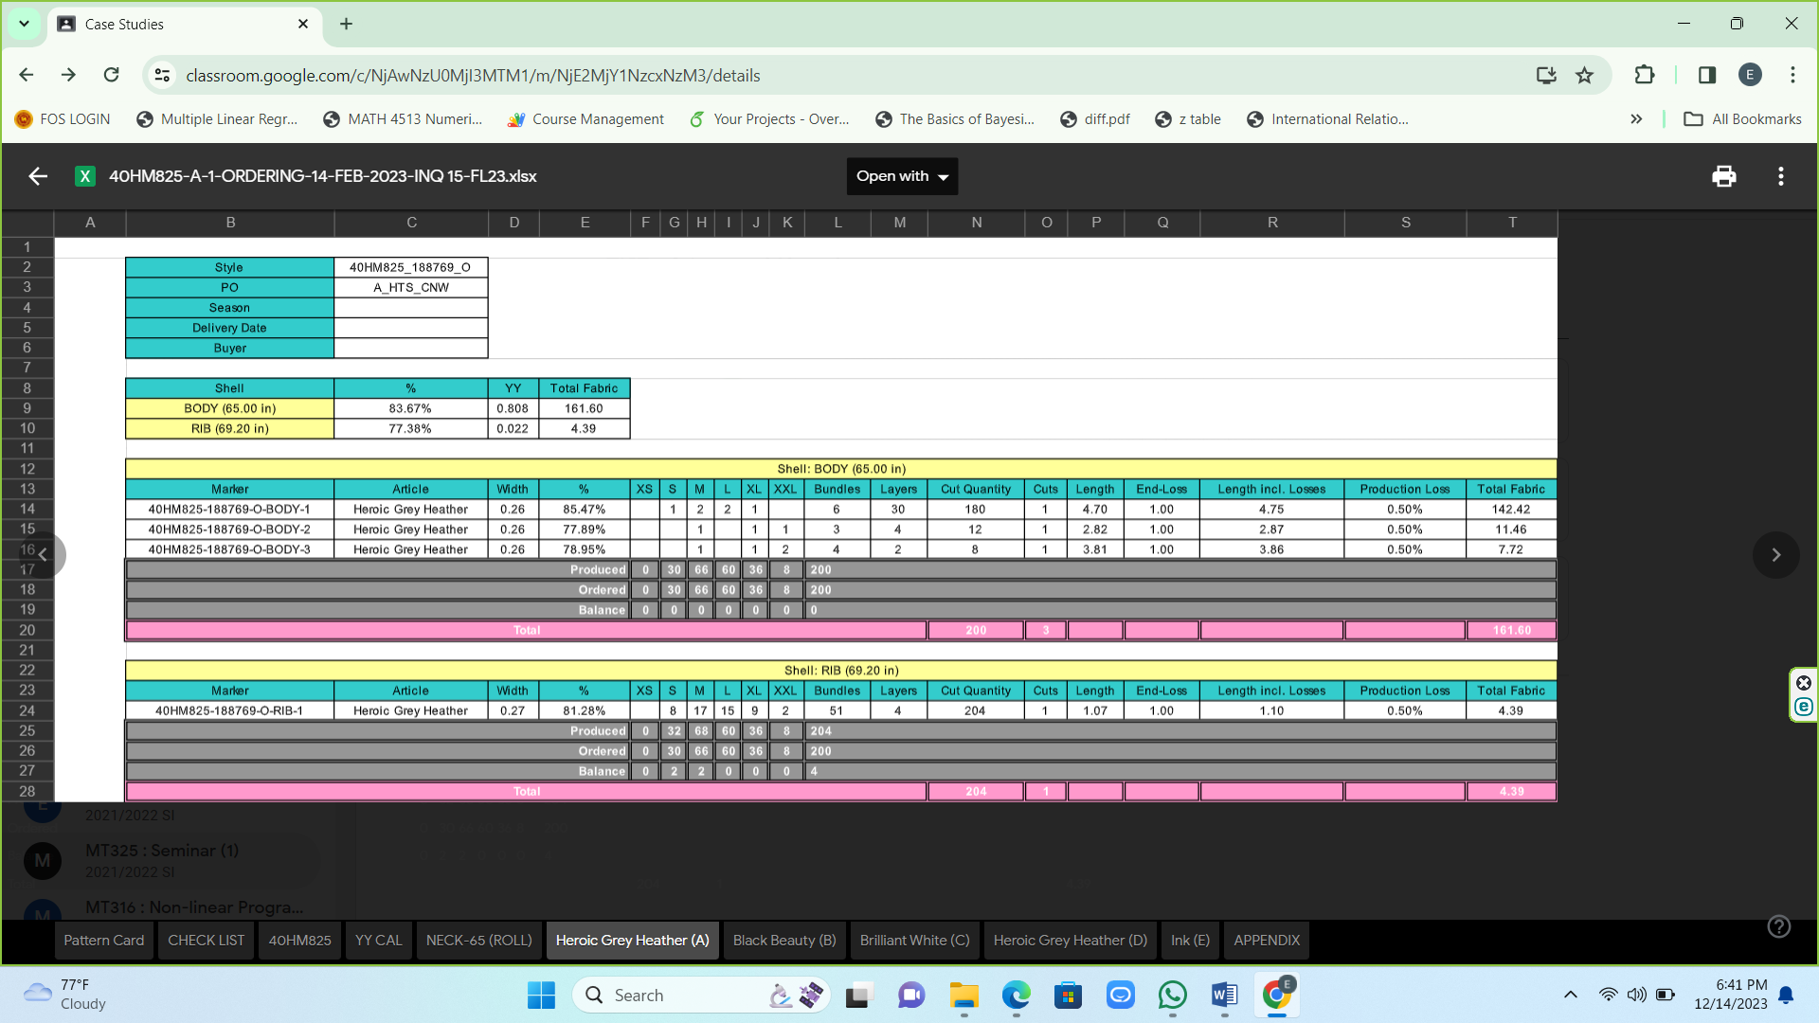

Layers

Efficiency

Fabric usage

Order quantity of each size

Our objective is to maximize the efficiency by optimizing the raw material usage.

i.e to satisfy the order by minimum the number of layers of fabric.

For that, we needed the following data.

* Order quantity of each size

Since we do not consider the limitations such as overlapping or sharp edges, order quantity of each size is the only required data here for our calculations.

Here, we discuss our output and findings for two garment designs.

# **Design one**

Following table shows the sizes and the demands.

|  |  |  |  |  |  |  |
| --- | --- | --- | --- | --- | --- | --- |
| Size(variable) | XS(x) | S(y) | M(z) | L(u) | XL(v) | XXL(w) |
| Demand | 12 | 36 | 72 | 72 | 36 | 12 |

Note that the variable here is the ratio of the particular size.

**Stage One**

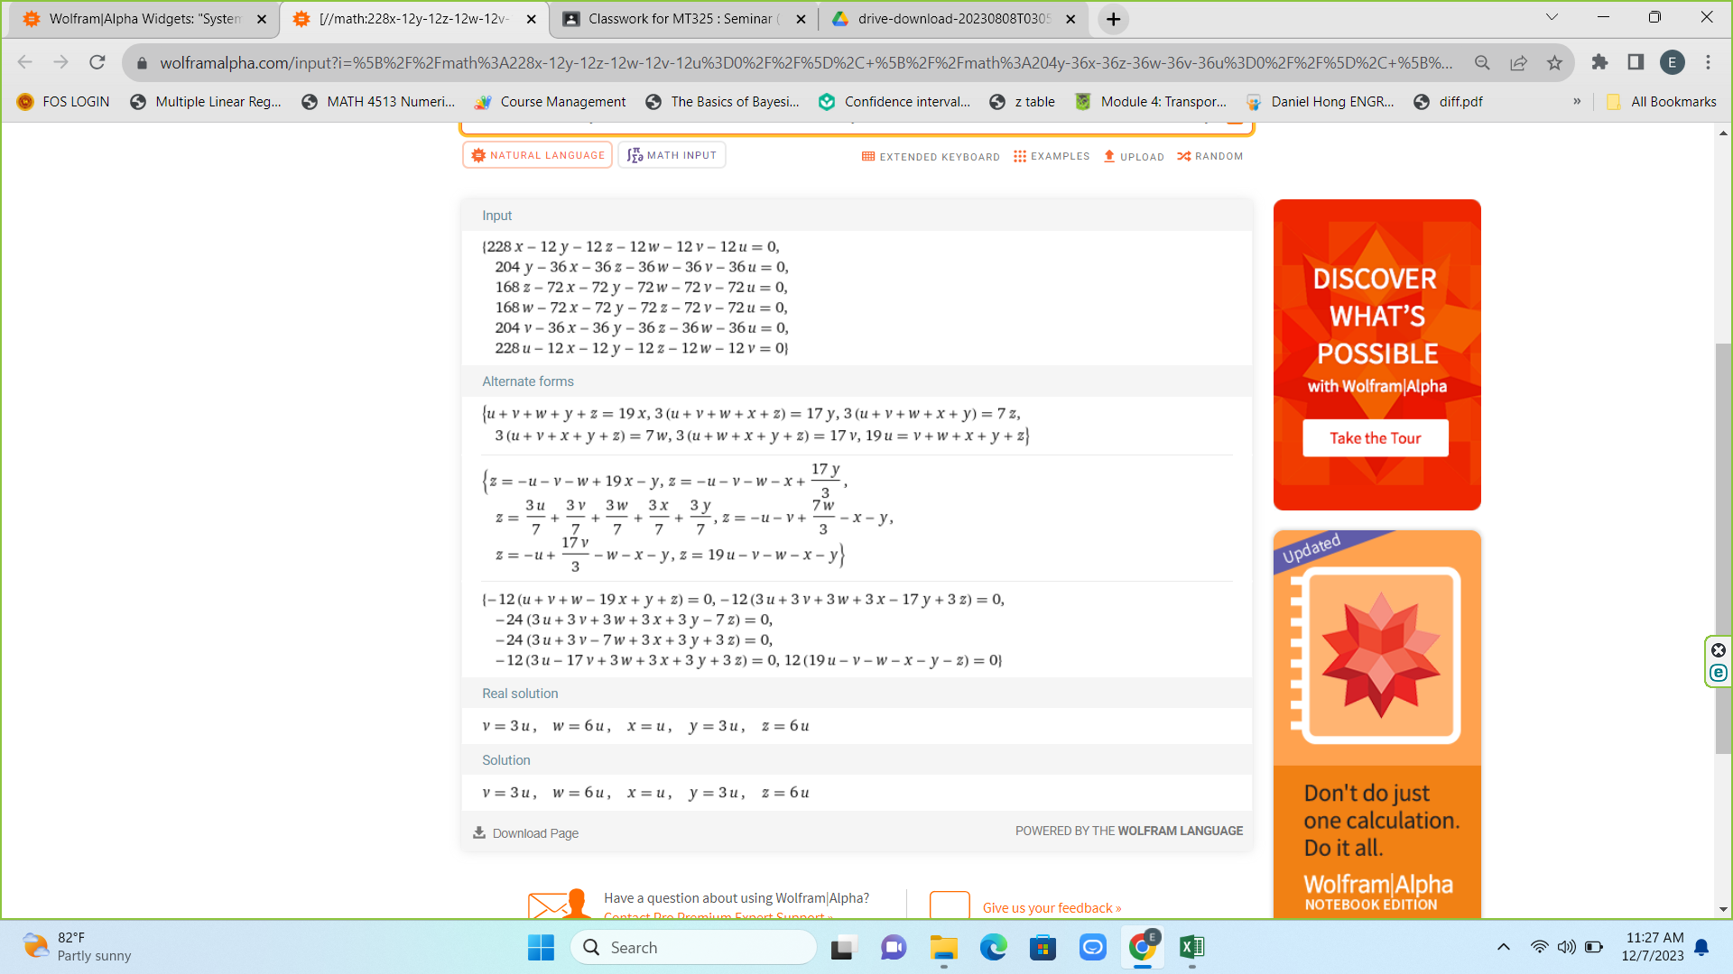By equation 3, we get the following system of linear equations to solve.

After solving we get the following result;



By substituting u = 1, we get the ratios as,

|  |  |
| --- | --- |
| Size(variable) | Ratio |
| XS(x) | 1 |
| S(y) | 3 |
| M(z) | 6 |
| L(u) | 1 |
| XL(v) | 3 |
| XXL(w) | 6 |

**Stage Two**

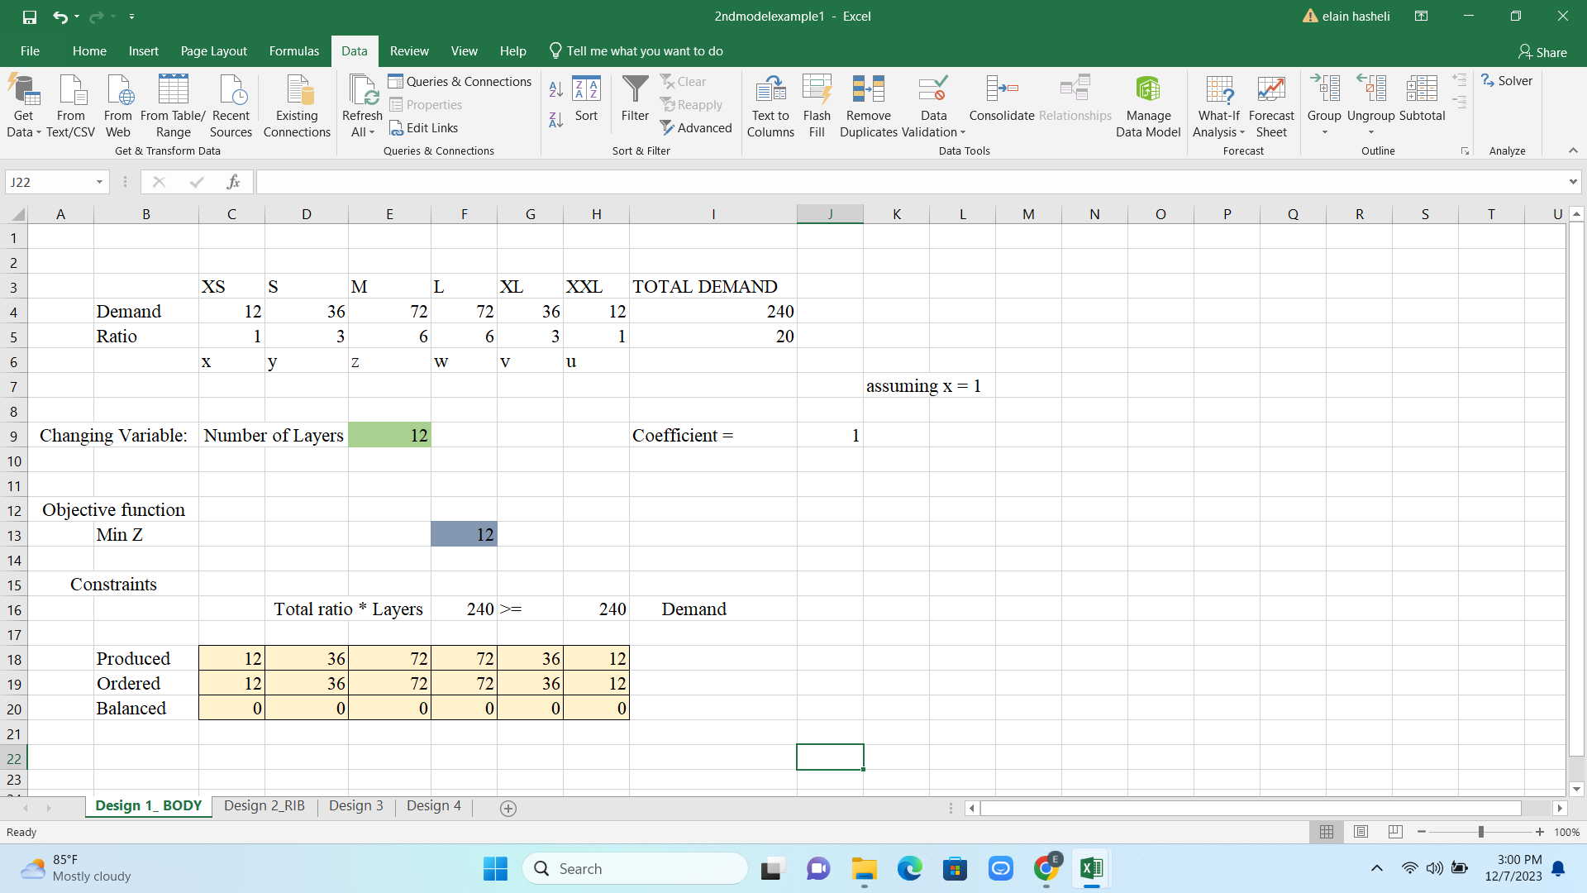Figure below is the output for the demand considered.

Demand constraint

Number of layers

Here the demand is satisfied by 12 fabric layers.

Note that for the calculations, marker length, overlapping and sharp edged are not considered.

# **Design two**

Following table shows the sizes and the demands.

|  |  |  |  |  |  |  |
| --- | --- | --- | --- | --- | --- | --- |
| Size(variable) | XS(x) | S(y) | M(z) | L(u) | XL(v) | XXL(w) |
| Demand | 72 | 192 | 468 | 504 | 240 | 120 |

Note that the variable here is the ratio of the particular size.

**Stage One**

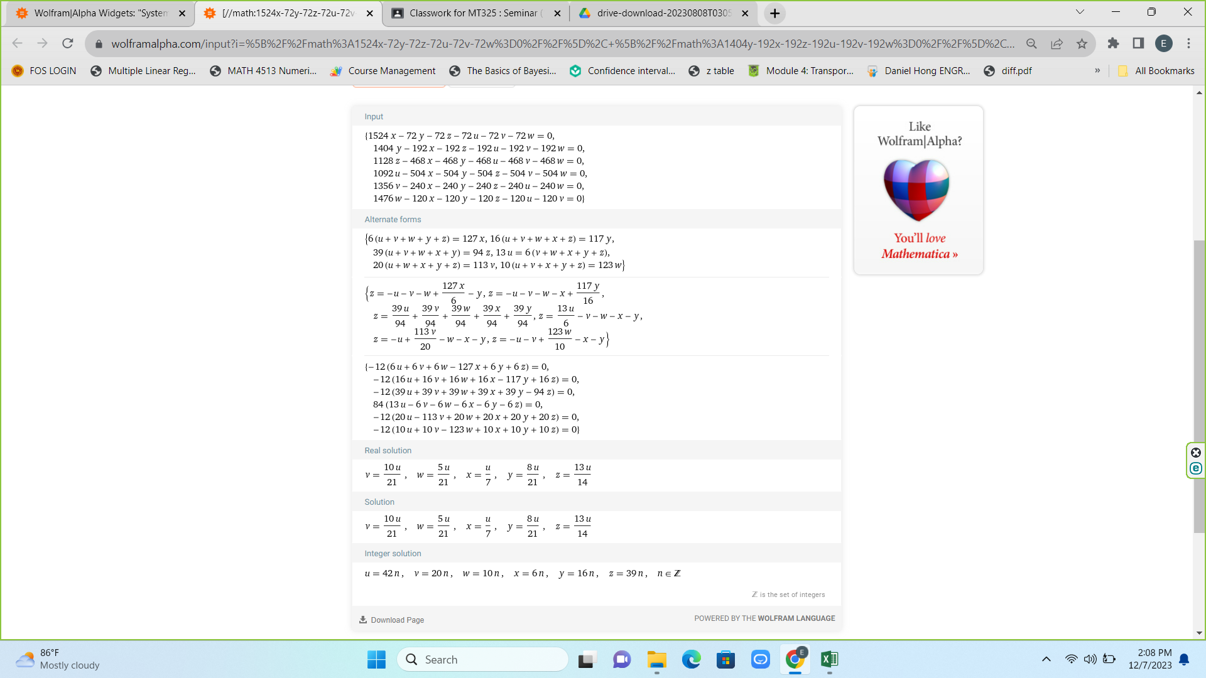By equation 3, we get the following system of linear equations to solve.

After solving we get the following result;

By substituting u = 22 and considering the integer part, we get the ratios as,

|  |  |
| --- | --- |
| Size(variable) | Ratio |
| XS(x) | 3 |
| S(y) | 8 |
| M(z) | 20 |
| L(u) | 22 |
| XL(v) | 10 |
| XXL(w) | 5 |

**Stage Two**

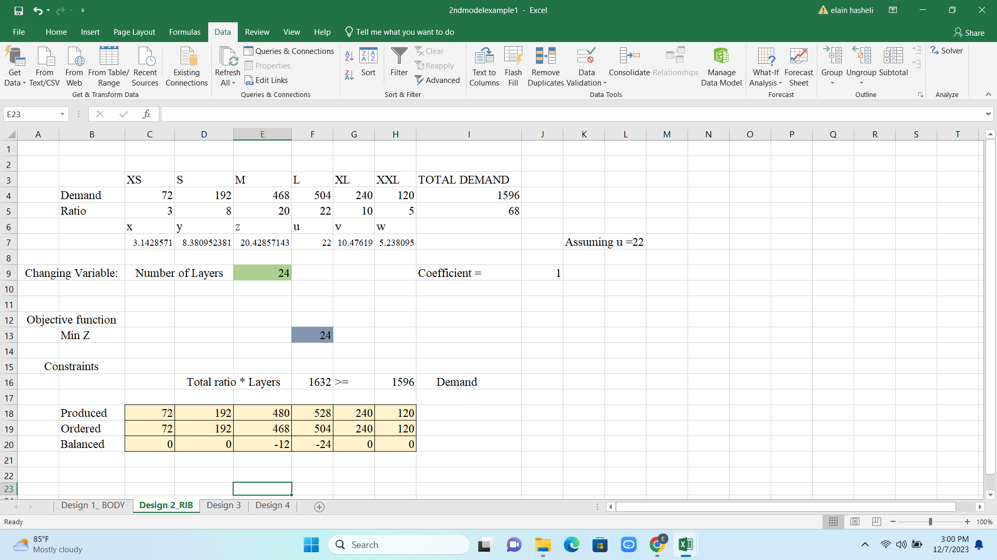Figure below is the output for the demand considered.

Overproduced

Number of layers

Demand constraint

Here the demand is satisfied by 24 fabric layers. There are 12 more pieces cut for medium size and 24 more pieces cut for large size. That over satisfied pieces are considered as wastage.

Note that, for the calculations, marker length, overlapping and sharp edged are not considered.

# **Conclusion and Future Work**

## **4.1 Assumptions**

While our results show encouraging results, it's important to acknowledge some of the assumptions that were made during the research.

* Non-Overlapping Patterns: We probably included no overlapping clothing pattern pieces in our model, which could have an impact on the practical use. Subsequent investigations may examine situations in which segments of the pattern coincide.
* Conditions for Solving the System of Linear Equations: One of the necessary for solving the system of linear equations is the assumption that the dependent variable, "u," is greater than or equal to 1. This condition can be seen in the equation y = 5u / 3; u ≥ 1.

## **4.2 Limitations**

Despite the positive results, our study has limitations that should be considered.

* Variable U Set of Values: Our approach involves assigning a set of values to variable "u" in order to find the best value to satisfy demand. This process may be resource-intensive, requiring the investigation of more efficient methods of value assignment.
* The Equation System Solution: We recognize the need for a better method of solving the system of linear equations. Current methodologies may have limitations that affect the optimization process's accuracy and efficiency.
* Generalization of the Model: Our model's generalization may be limited to specific conditions. Future research should look into ways to improve the model's applicability in a variety of scenarios.
* Length of the marker : There is a maximum length for a marker but in our model we have not considered it. We're prioritizing minimizing the layers over adhering to the marker length limit.

## **4.3 Conclusion**

The primary objective of this study is to minimize marker wastage in fabric used for garment production. Since less fabric consumption leads to the minimization of the fabric wastage in the marker making process methodology can be set to satisfying the demand using minimum number of fabric layers. This methodology clearly represents a correlation between size ratio values and number of fabric layers.

This methodology effectively addresses the challenge of marker wastage in garment production. By combining linear programming techniques with size-specific demand allocation, it ensures optimal resource utilization. The utilization of Excel Solver streamlines the solving process, making it practical for implementation in real-world scenarios.

## **4.4 Future work**

Our forthcoming strategy involves advancing the model to account for marker dimensions in the optimization of layer count. Additionally, we plan to implement a methodology to prevent overlapping and devise a solution for smoothing sharp edges. This expansion aims to enhance the model's precision and address potential challenges associated with marker dimensions, overlapping issues, and sharp edge irregularities.

# **References**

* External Supervisor : Mr. Dinesh Gunathilake – Brandix Fast Fashion Walisara
* <https://ejaet.com/PDF/4-10/EJAET-4-10-765-772.pdf>
* <https://textilelearner.net/techniques-or-methods-of-marker-making/>
* <https://hoshima-int.com/what-is-cutting-room-in-apparel-industry.html>
* [https://www.textileschool.com/193/garment-production-process/#:~:text=Apparel%20manufacturing%20process%20involves%20Product,Dyeing%20and%20Washing%2C%20QC%20etc](https://www.textileschool.com/193/garment-production-process/).
* [How to Calculate Size Wise Cut Quantity from the Size Ratio in an Order? (onlineclothingstudy.com)](https://www.onlineclothingstudy.com/2013/05/how-to-calculate-size-wise-cut-quantity.html)
* FinalModel.xlsx, RatioCalculation.xlsx
* <https://www.wolframalpha.com/examples/mathematics/algebra>